Scheduler
Table of Contents
Overview 1
Quick Start 2
And now in a little more detail... 3
Tasks 10
Positions 10
Adding Positions 10
Editing Positions 11
Deleting Positions 14
Volunteers 15
Adding Volunteers 15
Editing the Volunteer List 17
Editing Dates 20
Scheduling 23
Generating Schedules 23
Viewing Schedules 24
Editing the Schedule 26
Send Updates 27
Sending Information Update Requests 27
Sending Schedules 28
Sending Weekly Reminders 29
Administrative 30
Backups 30
Making Backups 31
Restoring From Backups 31
Automatic Reminders 31
System Settings 32
Entering Gmail information 33
Setting up a Gmail account for Scheduler 34
Setting up an app password for Scheduler 34
Twilio Information 37
Administrator Contact Info 38

Overview
Scheduler is a program written to help automate the process of scheduling volunteers for church activities. It is written to be accessible via browser so that it may be easily used from an office, from home or even from cell phones. The code is written to allow you to:
- Define a list of volunteer positions that need to be filled and when the volunteer should arrive.
- Define a list of volunteers. Volunteers may specify:
  - Days when they are unavailable.
  - Days when they would prefer to serve (say for instance, their daughter would be visiting and they would like to serve communion together).
  - Positions that they would like to volunteer for.
  - How they wish to be contacted (email, text, or both).
- Generate schedules for a given date range.
- View schedules for a given date range.
- Send requests to volunteers (via email or text message) to ask them to update their information before a new schedule is generated.
- Send a personalized list of service dates to volunteers (via email or text).
- Send reminders (via email or text) to volunteers who are scheduled to serve within the next week.
Note that for sending messages, Scheduler uses Gmail to send email and the service Twilio for sending SMS text messages. Twilio was chosen because of their reputation, programming support, and low cost. They bill only for messages sent—there is no membership or monthly fee required.

Quick Start
Here is a quick summary of the steps in getting started, with more detail following:
- At the login screen, use the default login name of “volunteer” and the password “dates”.
- From the main menu, select Positions and define an entry for each position that is needed. Note that for each position you can indicate how many people are needed to fill that role on a given date.
- From the main menu, select Volunteers and from that page, make an entry for each person who wishes to volunteer. For each person you can enter their name, email, phone number, how they prefer to be contacted, position(s) that they wish to volunteer for (selected from the previously defined list) and optionally any dates for which they are not available, or dates when they would prefer to be chosen to volunteer.
- If you wish to allow individuals to update their information before generating a schedule, select Send from the menu bar, and select Send Info Update Requests from the drop-down menu. This will send email and or text messages to each volunteer asking them to update their information and providing them a browser link that they can use to make the updates.
- When ready to generate a schedule, select Schedule from the menu bar and select the Generate Schedule item from the drop-down menu. This will direct you to a page where you may specify the dates to generate the schedule for. A schedule will be generated and you will be directed to the “View Schedule” page. If all positions were filled, the program will send personal schedules to each person in the schedule, with the dates when they are requested to serve and the positions that they will fill.
- If the schedule has some positions which were not filled, you will need to fill them manually and once the schedule is complete, you can select the Send and Send Schedules items on the menu bar to send schedules to each volunteer.
- To send reminders to volunteers each week, simply click Send and then Send Weekly Reminders from the drop-down menu. Each person who is scheduled to volunteer that week will receive a reminder via text or email.

And now in a little more detail...
To begin using Scheduler for the first time, start by connecting to the web page, which should look something like this:

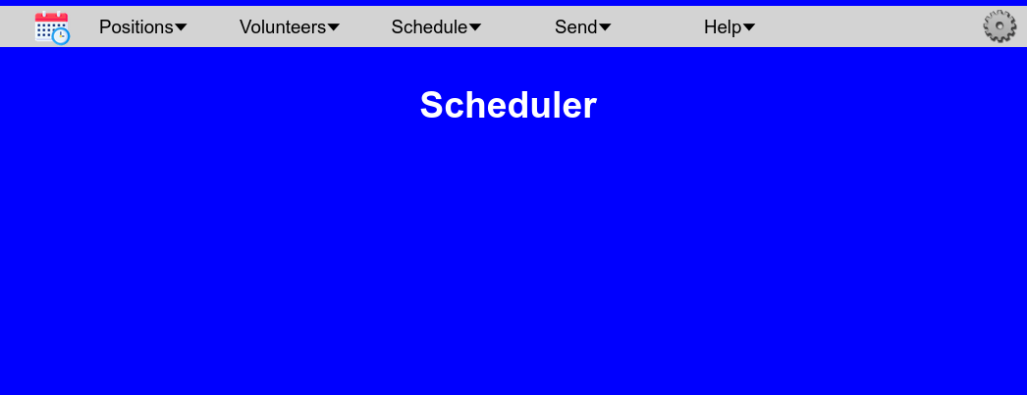

In the top left corner is the Scheduler icon. Clicking on this icon will return you to the home page. As your first time using the system, you should begin by clicking on the Positions menu item, and select the Add Positions entry. This will direct you to a screen that looks like this:
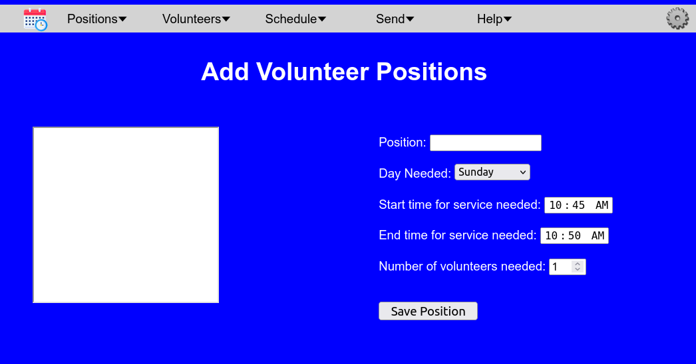

The box on the left will show the names of volunteer positions, but initially, it is empty. From this screen you will define the positions that need to be scheduled. Note that the positions have a start and end time. The reason for this is so that (if desired) a person could serve in two different positions during a service, so long as they don’t overlap. For example, a person might serve as a greeter who stands at the front door to welcome people as they arrive, but later will be reading a scripture during the service. By assigning approximate start and end times for the position, it makes it possible to schedule these events. When you have filled in the appropriate fields, click the Save Position button to add that position to the list. Continue adding and saving entries into the table until all of the positions that need to be scheduled have been defined.
Next you will want to enter all of the volunteers. To do so, click on Volunteers in the menu bar at the top of the screen and select the Add Volunteers entry from the drop-down menu, It will direct you to a screen that looks like this:
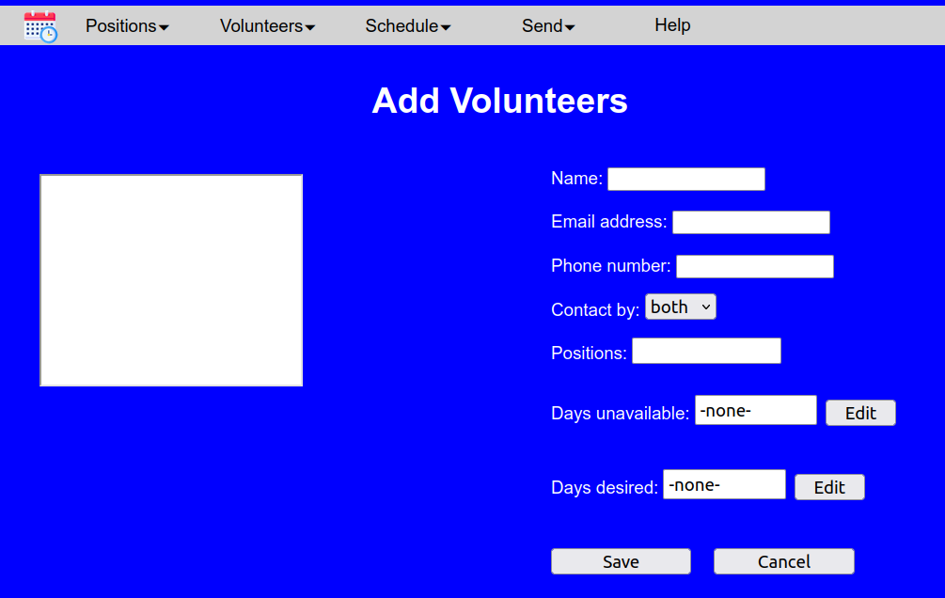
From here you can enter the information for each volunteer. If possible provide both email address and the phone number to receive texts and select whether the Scheduler program should contact this person by text, by email, or both. The “Positions” entry will include the position titles that you provided while building the positions table. Make sure that you select at least one of the positions for the person to volunteer for. Multiple selections from the list are possible by holding down the control key while you make a selection.
When you have entered the information for a volunteer, click the save button. The program will save the information and clear the fields so that you may enter another volunteer. Continue adding volunteers until all volunteer names have been entered.
At this point, you may wish to give your volunteers the opportunity to review the information and possibly update it. You may send out requests to all of the volunteers in your list asking them to to update their information by clicking on the Send item on the menu bar and selecting Send Info Update Requests from the drop-down menu.

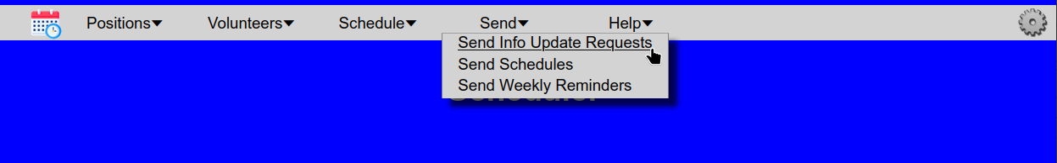
Each person from the volunteer list will receive an email or text asking if they need to update their information, along with a link which will let them update their information.
Once all of the volunteer information has been verified, you are ready to generate a schedule. To do so, select Schedule from the menu bar and select Generate Schedule from the drop-down menu. You will be directed to a screen like this, that asks you to enter the first and last dates to include in the new schedule.

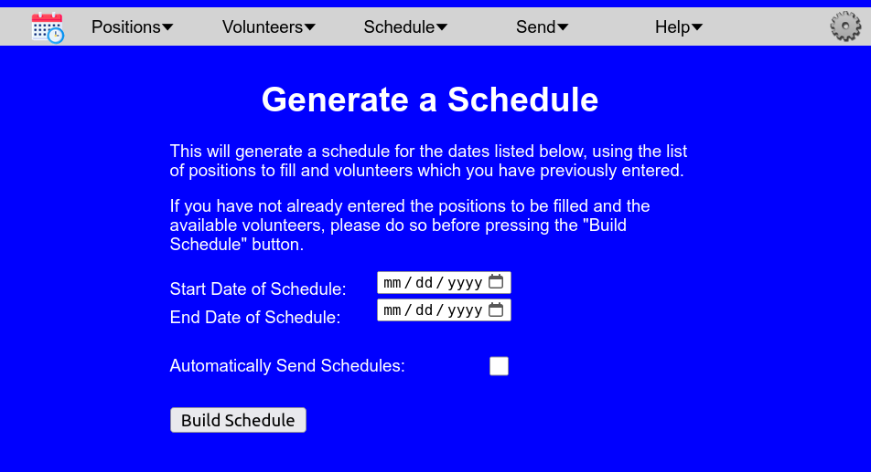

From this screen, enter the starting and ending dates. You may enter numbers into the mm / dd / yyyy fields or click the calendar icon to be provided with a calendar for selecting the dates. Note that the dates are inclusive, so if, for example, you select 01/05/2025 and 01/26/2025 as the starting and ending dates, both of those dates will be scheduled (if those are weekdays that you have positions to fill). If you would like for Scheduler to send an email or text to everyone who gets scheduled with the dates when they are scheduled to serve, click the “Automatically Send Schedules” box. When you have finished, press the Build Schedule button.
Scheduler will then calculate the dates when positions need to be filled and try to find a volunteer to serve in each position for each of those dates. When it has finished, it will show you the schedule that it generated. The screen will look something like this:
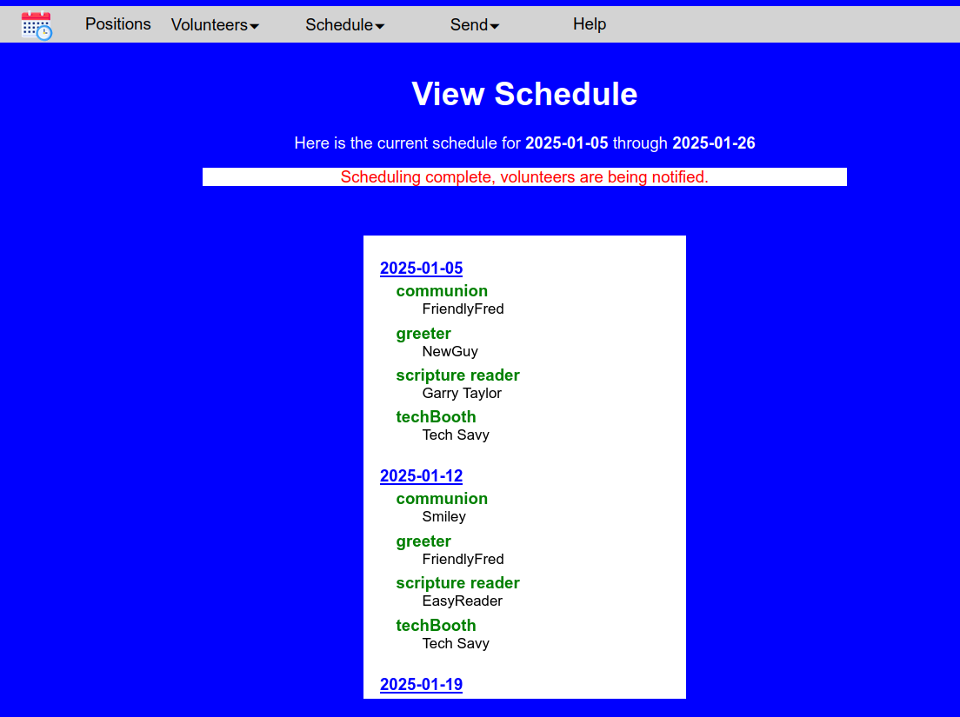
If Scheduler was able to fill all of the slots, it will display the message saying “Scheduling complete” if you chose to send the volunteers their new schedules, it will also say “volunteers are being notified,” and all of the people in the schedule will receive a message telling them the dates that they are scheduled to serve and the positions that they will be filling.
If the Scheduler was not able to fill all of the slots, the screen will look like this: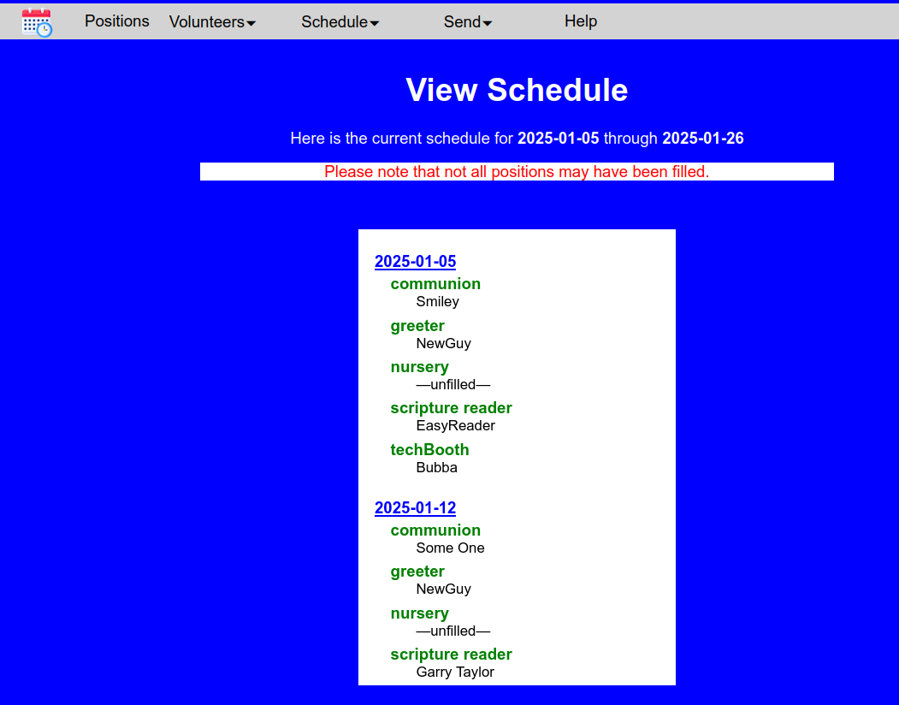
with the message indicating that all slots were not filled. Note that if this occurs, Scheduler will not automatically send out schedule notices to the volunteers, since some changes may first need to be made to the schedule. If this occurs, you may need to manually edit the schedule. To do so, click on the name (or “—unfilled—“) and an edit box will pop up showing you the names of all volunteers who offered to work in this position.
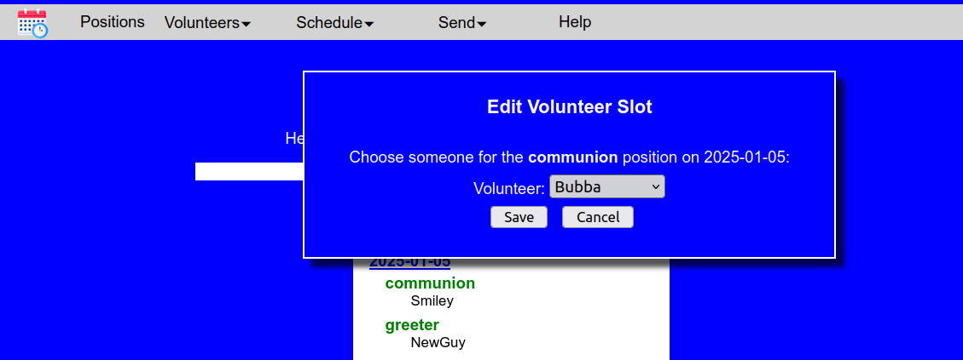
Pick one of the names from the drop-down list of volunteers and press the Save button to save the change to the schedule.
When you have completed the changes to the schedule, you may then want to send the personal schedules to each of the volunteers. To do so, select Send from the menu bar and click the Send Schedules entry.

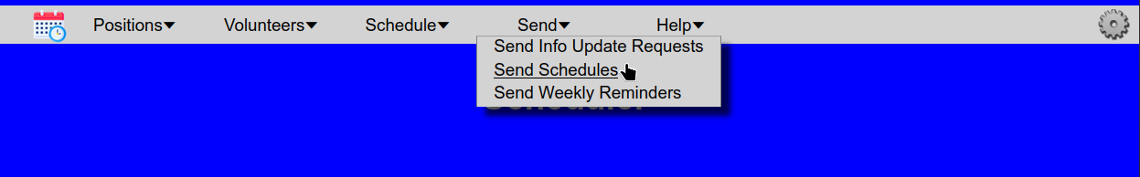
You will be redirected to this screen, where you can enter the start and end dates of the schedule that you wish to send out.
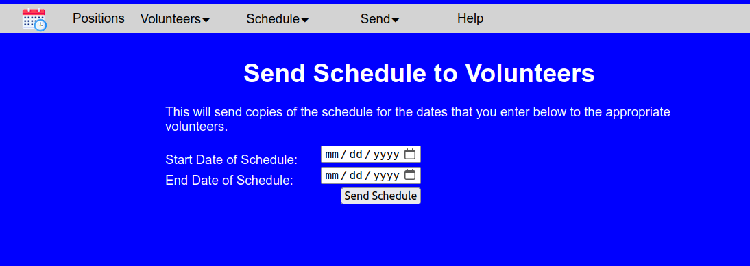
Select the starting and ending dates and then press the Send Schedule button to send out the personal schedules to each volunteer who was scheduled.
Each week, you may wish to send out reminders to the volunteers who are scheduled to work that week. To do so, click the Send entry on menu bar and then select Send Weekly Reminders.

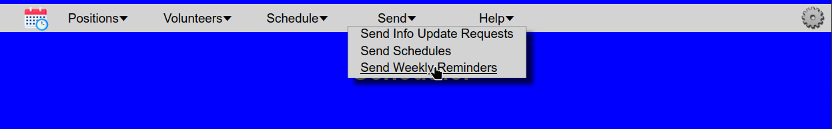
This will cause Scheduler to send out a reminder to each person scheduled to work that week, reminding them of the position that they will be filling and when they are needed. Note that Scheduler keeps track of who it has sent reminders to, so if you accidentally do this more that once in a week, it will not send out duplicate reminders. (Note that, if you desire, you can configure Schedule to send these reminders automatically each week.)

Tasks

Positions
Positions are the roles that need to be filled by volunteers. Scheduler allows you to define a position by name, specifying the time and day of the week that the position needs to be filled. It also allows you to specify the number of volunteers needed to fill the role. So, for instance, you may need only one person to fill the role of “Scripture Reader”, but you may need four volunteers to assist with communion.

Adding Positions
To add positions to the list, select on the Positions menu item, and select the Add Positions entry. This will direct you to a screen that looks like this:
The box on the left will contain the names of any positions which were previously defined. To add a new position, simply fill out the fields on the right. In the “Position:” field, enter the name that you wish to use for this position, for example “Greeter”. Note that the positions have a start and end time. The reason for this is so that (if desired) a person could serve in two different positions during a service, so long as the tasks don’t overlap. For example, a person might serve as a Greeter who stands at the front door to welcome people as they arrive, but later , during the service, the same person could read scripture. By assigning approximate start and end times for the position, it makes it possible to schedule these events. When all fields are entered, press the Save Position button. A popup box will confirm that you wish to add the value. Once the value is added, the position will be added to the list on the left and the fields will be reset so that you may enter a new position value, if you wish.

Editing Positions
You can edit the list of positions to change the values of existing entries, or to remove entries from the list. To edit positions, select Positions from the menu bar and then select the Edit Positions entry. You will be directed to a screen similar to this:

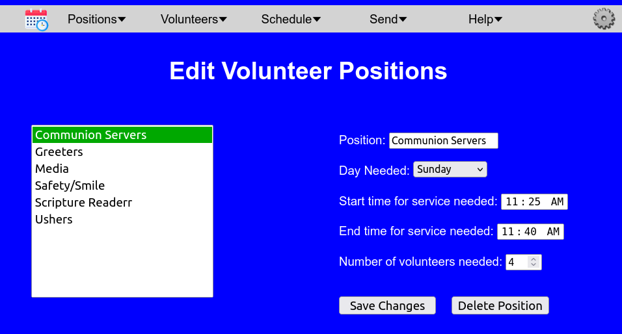

As you can see in this example, there was a typo in the name of the “Scripture Reader” position. To correct it, click on the entry in the box on the left.
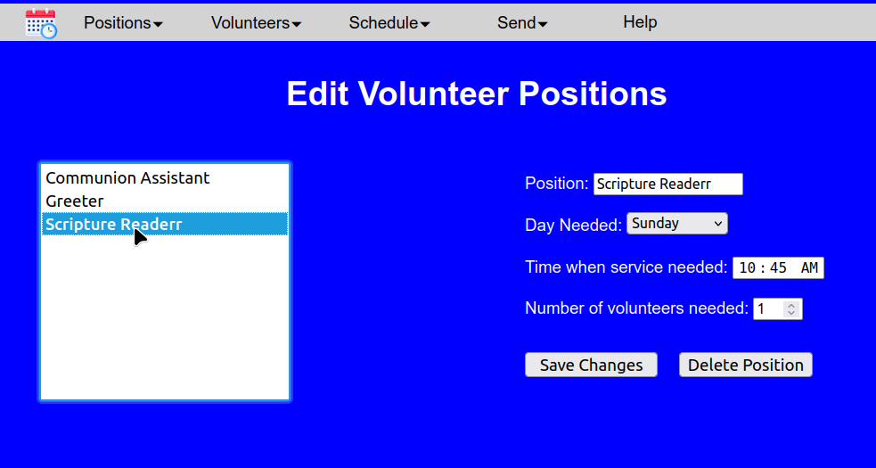
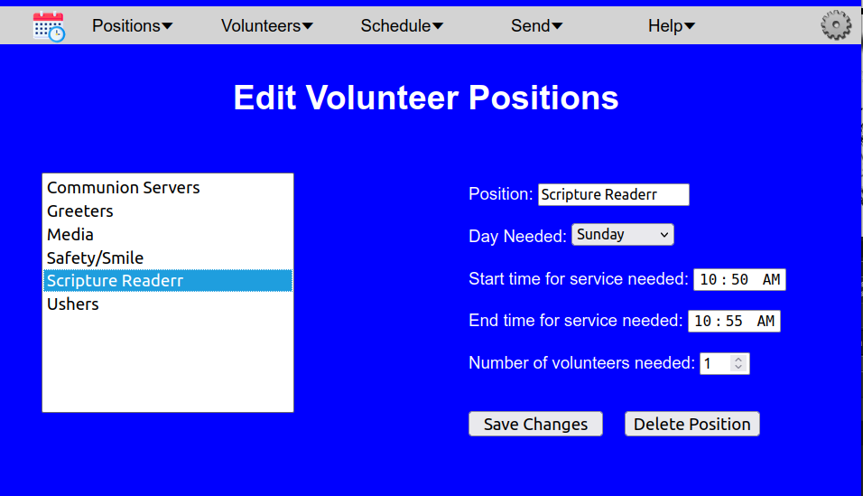
As you can see, the fields on the right are updated to show the values for this position. Correct the title in the “Position:” field, and then press the Save Changes button. You will be prompted to confirm the save, and if you press the Save Changes button, the list will be updated to reflect the change.

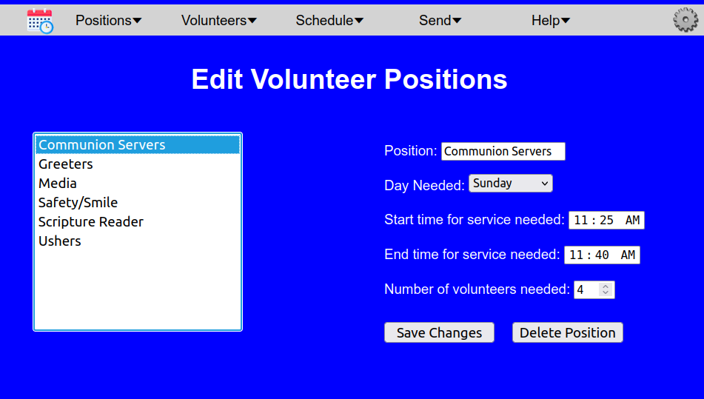

Deleting Positions
If you need to remove a position from the schedule, select Positions from the menu bar and then select the Edit Positions entry. You will be directed to a screen similar to this:

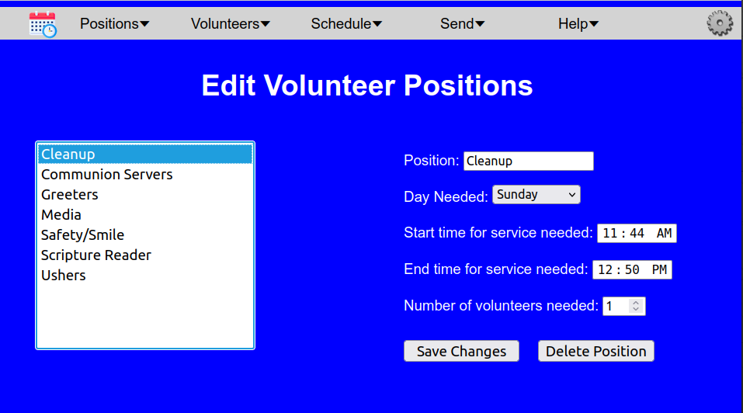
Select the entry that you wish to remove from the list on the left, and then press the Delete Position button. When prompted if you wish to delete this entry, select “Yes”. The position will be removed, and the list will be updated to reflect the change.

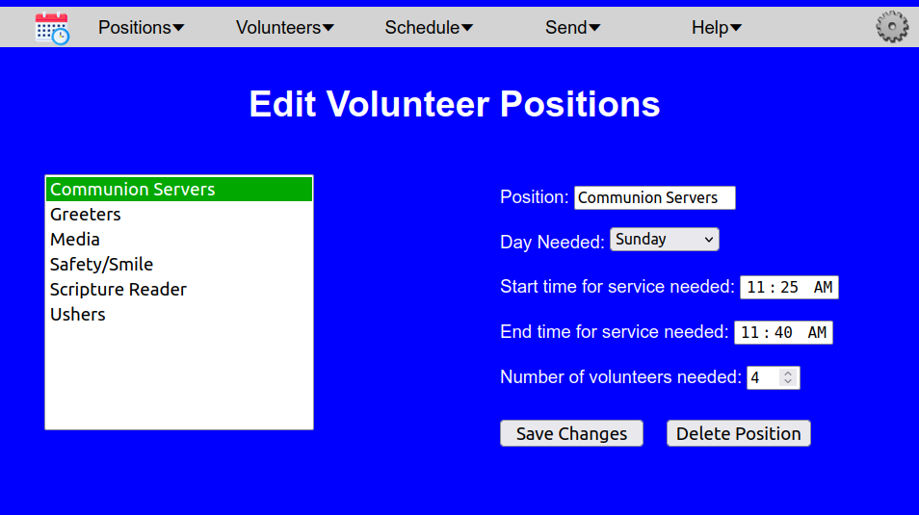

Volunteers
Volunteers is a list of the people who have signed up to fill the various roles in the schedule. With Scheduler, each volunteer can specify days when they are unable to volunteer, and they may also specify days when they specifically wish to volunteer. For each volunteer, the email address and the cell phone number of the volunteer are tracked, along with how the volunteer wishes to be contacted (by email, text, or both). The Scheduler program will use those values to send copies of the schedule to volunteers, along with reminders for when they are scheduled to serve.

Adding Volunteers
To add names to the volunteer list, click on Volunteers in the menu bar at the top of the screen and select the Add Volunteers entry from the drop-down menu, It will direct you to a screen that looks like this:
From here you can enter the information for each volunteer. If possible provide both email address and the phone number to receive texts and select whether the Scheduler program should contact this person by text, by email, or both. The “Positions” entry will include the position titles that you provided while building the positions table. Make sure that you select at least one of the positions for the person to volunteer for. Multiple selections from the list are possible by holding down the control key while you make a selection.
If the person has dates which they are unavailable to serve, or dates for which they would specifically like to serve, you may enter those in the “Days unavailable” or “Days desired” fields by pressing the Edit button next to that field. For more information on entering the dates, see the Editing Dates section.
When you have entered the information for a volunteer, click the save button. The program will save the information and clear the fields so that you may enter another volunteer. Continue adding volunteers until all volunteer names have been entered.

Editing the Volunteer List
To edit an entry in the volunteer list, click the Volunteers entry in the menu bar and select the Edit Volunteers item. You will be directed to a screen like this: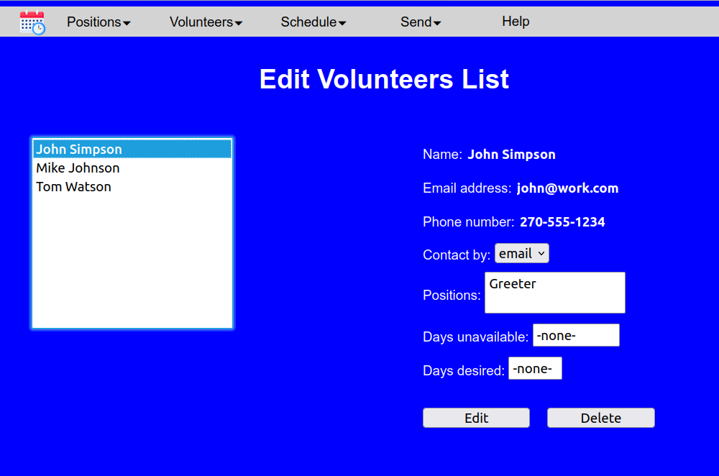
The box on the list will show a list of all volunteers entered into the system. To edit a volunteer, click on the name in the left hand box, and the fields will update to reflect that person’s entries. For this example lets say Mike Johnson needs his entry changed so that he is only notified by email. First, click on the entry for Mike Johnson. You will see the screen updates to show his information:
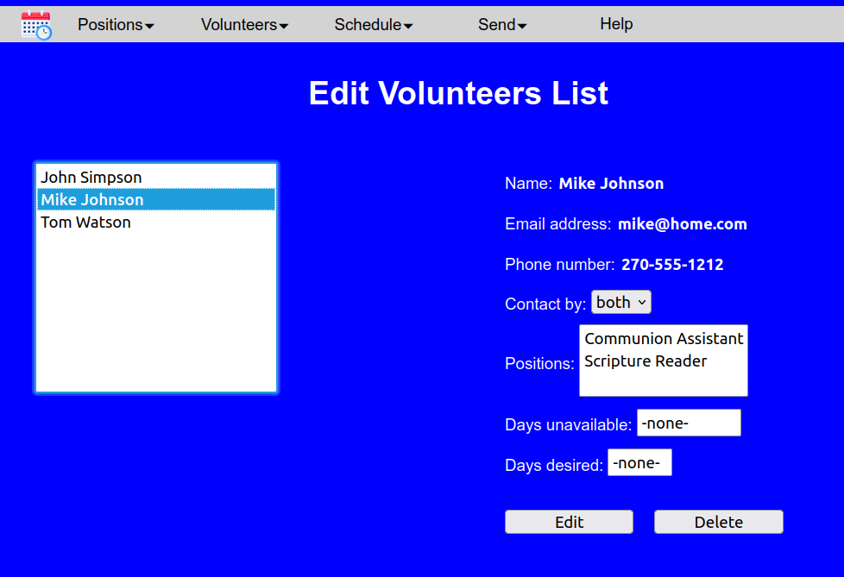
You can see that the “Contact by” field for Mike is currently set to “both”. To change it, press the Edit button. The screen will switch to one like this:
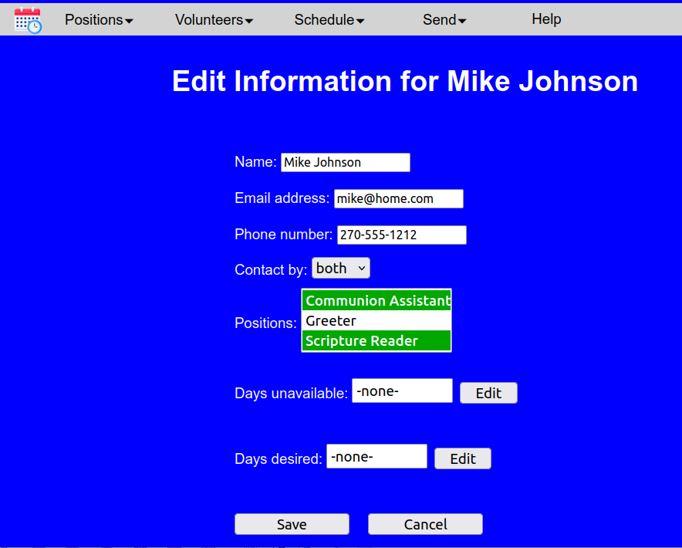
All of these fields are now editable. So to change the contact method, click the down arrow beside “both” and click on the “email” entry. When you are finished, press the Save button, and when prompted, click Ok to save the changes. You will then be returned to the “Edit Volunteers List” screen.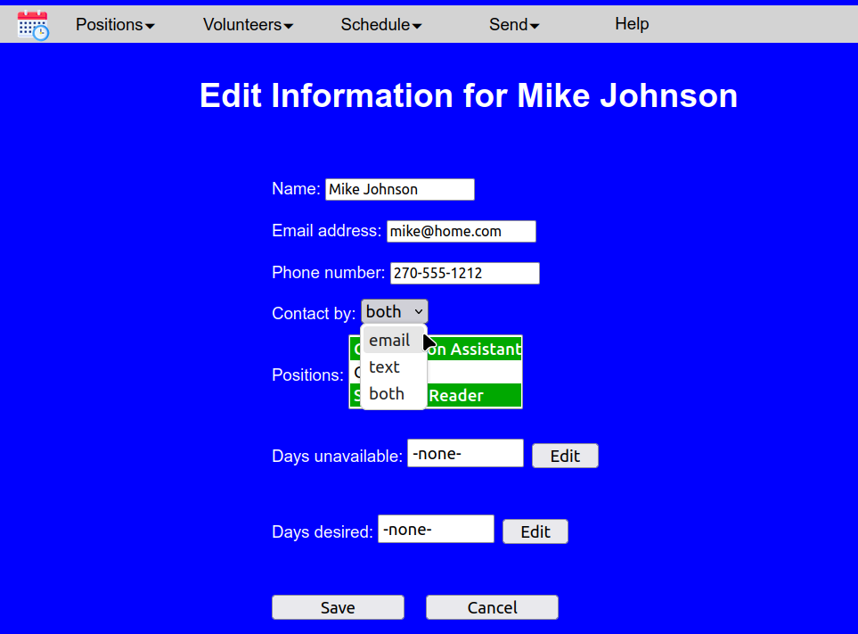

Editing Dates
The date fields allow you to enter dates when someone is unavailable to volunteer, or someone wishes to volunteer on a specific date. Let’s say from our previous example, that Mike is going to be unavailable on January 1st. To make this change, select Mike’s entry as described above, and on the edit screen, click the Edit button next to “Days unavailable:”. A popup box like this will appear:

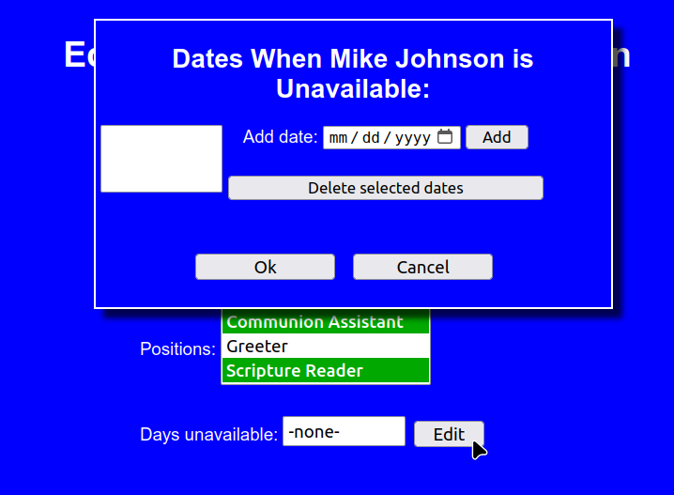
The box on the left will contain any days which Mike had previously listed as unavailable. If you wish to remove any of those dates, simply select it, and press the Delete selected Dates button. To add January 1st to the list, click in the field next to “Add date”. Depending upon your browser, you will have the option of either entering the values in the “mm / dd / yyyy” fields, or be presented with a calendar from which you can select a date.
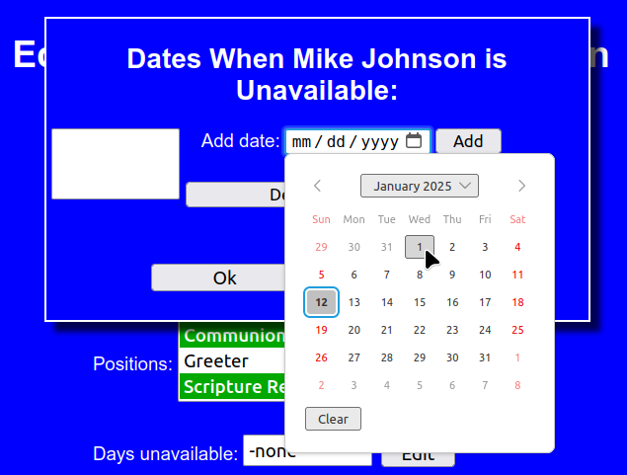
When the date is chosen, press Add and the date will be added to the list on the left.
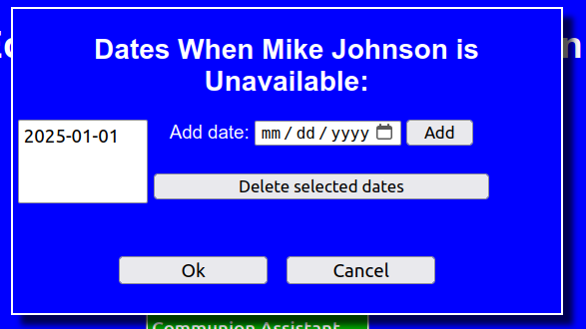
Continue editing the dates. When you are finished, press Ok and the changes will be copied to the date field on the edit screen.
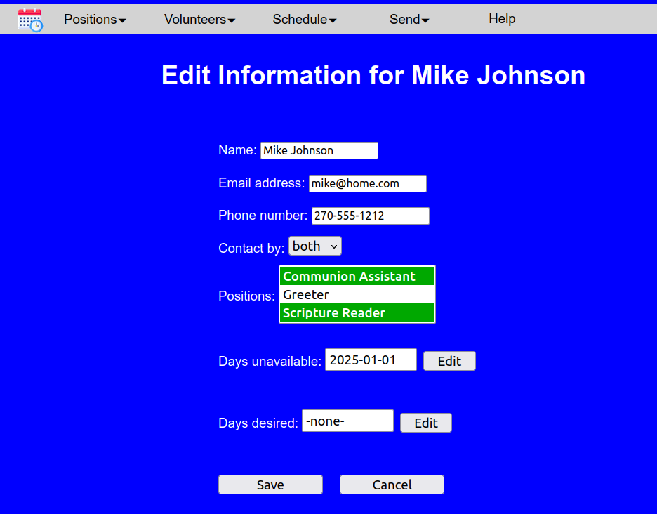

Scheduling
When positions have been created and volunteers entered, you are ready to generate a schedule. From the Schedule menu you can create new schedules, view schedules, and edit existing schedules.

Generating Schedules
To do so, select Schedule from the menu and then select Generate Schedule.
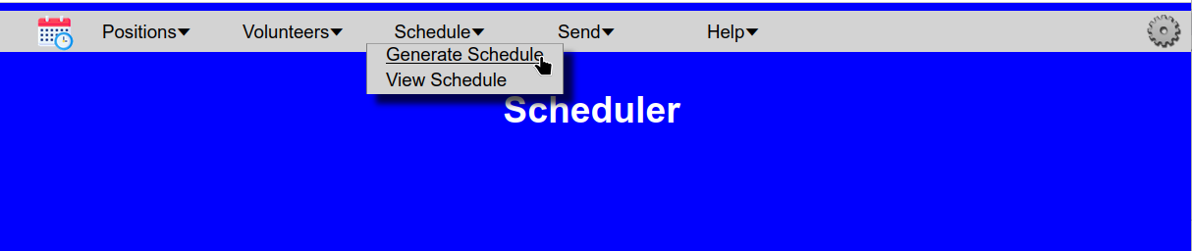
You will be presented with the following screen:
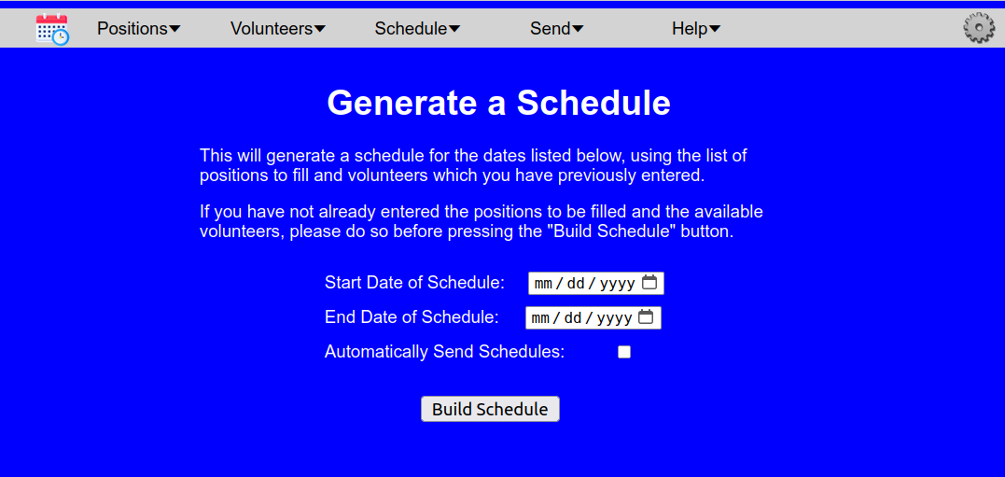
Scheduler will build a schedule using the start date and end date that you provide on this screen. Note that the start date and end dates are inclusive, so if you selected 01/01/2025 as the start date and 01/02/2025 as the end date, the schedule would include both Jan. 1, 2025 and Jan. 2, 2025. The schedule that it generates will overwrite any previously existing schedule that may have existed on those dates. Because of this, before generating the schedule, if it finds an existing schedule for one or more of the dates, it will display a warning screen like this:
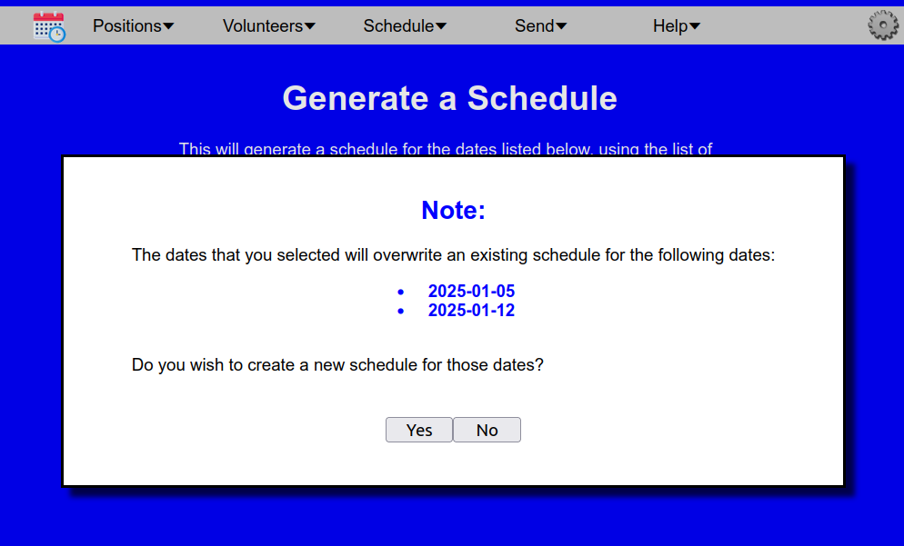
giving you the option to overwrite the previous schedule if you desire.
The initial screen also provides you the option of automatically sending schedules to each person who is scheduled to volunteer in the new schedule that it generates. The schedules will be sent to each volunteer by either text or email, as was indicated in their volunteer preferences. The message sent will include the dates and roles that that person has been selected for each position that they are scheduled for within the newly generated schedule.
Once you have entered the start and dates, click the Build Schedule button and a new schedule will be generated and you will be directed to the View Schedule page.

Viewing Schedules
The View Schedule page lets you see the schedules that have been set for any range of dates that you specify. To view a schedule, select Schedule from the main menu, and the View Schedule
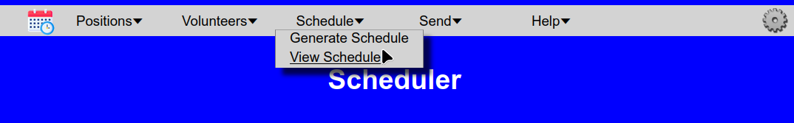
This will take you to the View Schedule screen:
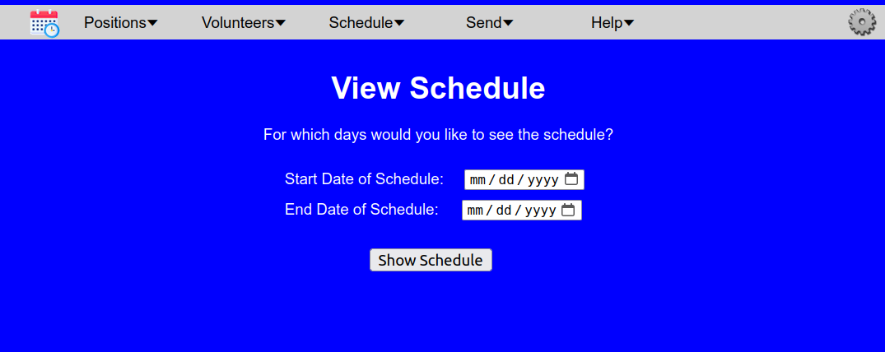
From here you can enter range for the particular dates of the schedule that you would like to see. As with generating a schedule, the date values that you enter here are inclusive. When you have entered values for the start and end dates, press the Show Schedule button. It will then show you the schedule for the dates. It should look something like this:

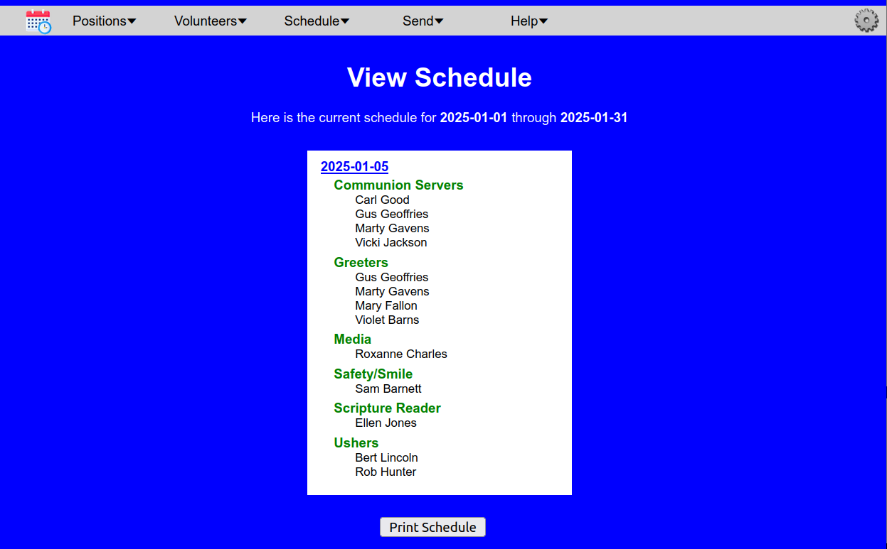
The top of the screen shows the range of dates displayed. The white box in the center shows the dates, positions, and the volunteers scheduled to serve in those positions. The box in the center can be scrolled to let you see the volunteers on all of the requested dates. If you would like to have a printed copy of the schedule, simply press the Print Schedule button at the bottom of the screen.

Editing the Schedule
Be aware that when you are viewing the schedule, you have the ability to change the person scheduled for each slot. Let’s say that after generating our schedule above, Roxanne Charles got sick and sent word that she would be unable to serve on Jan. 5th. You can edit the schedule to put someone else in that slot. To start, go to the View Schedule page, and select dates which will show the date you need to change (in our example, 01-05-2025). You screen should look something like this:
Then use the mouse to click on name of the person you need to change (in this example, Roxanne Charles). The screen will update to show you the Edit Volunteer Slot box:
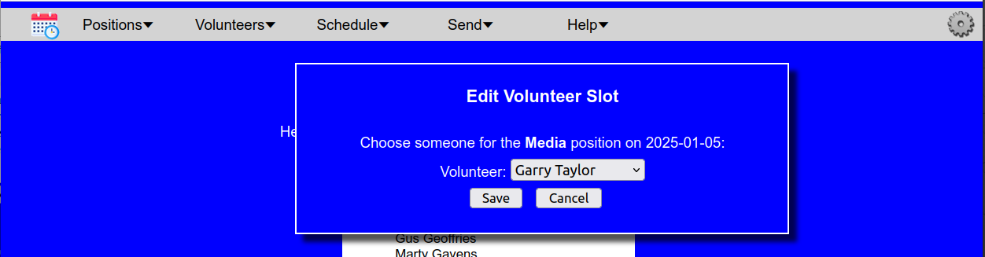
Here you will see the date and position to be filled, along with a list of volunteers who have signed up to work in this position. From the drop-down box, select the name of the person to fill this position, and then click the Save button to make the change to the schedule. The schedule will then be updated to reflect the change:
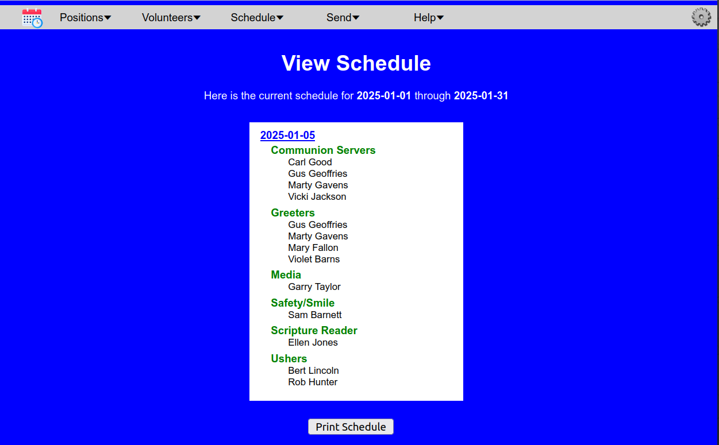

Send Updates
The Scheduler program not only schedules volunteers, but also allows you to send communications to your volunteers so that everyone is up to date with the latest scheduling. Scheduler allows three different types of communications, which may be sent by SMS text, email, or both, based on each volunteer’s preferences. The types of communication are volunteer information update requests, individual schedules, and service reminders. These are all found under the Send Updates menu entry.

Sending Information Update Requests
For the Scheduler program to do a good job of scheduling volunteers into needed positions, it needs to have an up-to-date list of days when a volunteer will not be available, or days when they may specifically want to work. For that reason, Scheduler allows you to send out requests to volunteers, asking them to update their information. You may wish to use this feature before generating a new schedule. The Send Info Update Requests menu item will send out a notification to each volunteer, using SMS text, email, or both as they prefer. The request will look something like this:
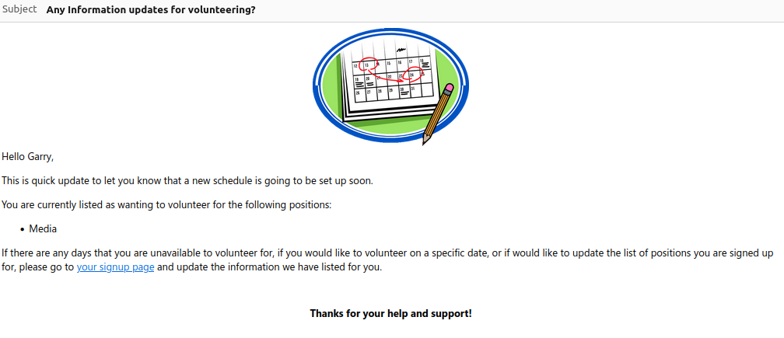
The notice will show the positions that they have signed up for and provides a link that they can use to go into the Scheduler program and update their information. (Note that when using this link, the volunteer will not be able to access anything other than their information.)

Sending Schedules
The schedules will be sent to each volunteer by either text or email, as was indicated in their volunteer preferences. The message sent will include the dates and roles that that person has been selected for each position that they are scheduled for within the specified dates. So, for instance, if Garry were scheduled to serve in the “Media” position on April 6th and April 20th, he would receive an email like this:
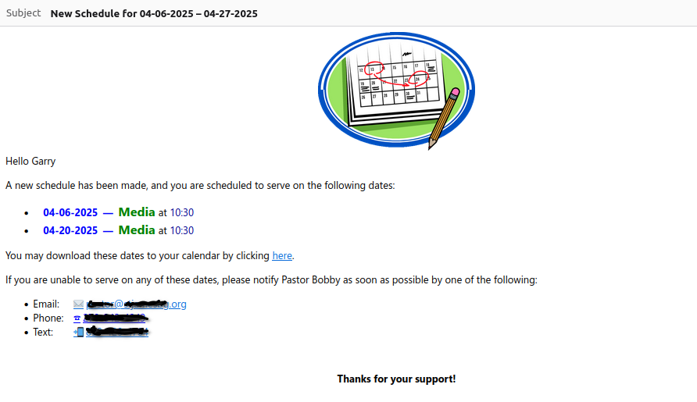

Sending Weekly Reminders
Scheduler can send out a reminder to everyone who is scheduled to work in the next 6 days to remind them of their schedule. To do so, select the Send Weekly Reminder menu option. Each person who is scheduled to volunteer that week will receive a message via SMS text or email (based on their preference) reminding them of their scheduled time. Scheduler will keep track of everyone that it has sent reminders to this week, so that you do not have to worry about sending someone multiple reminders by mistake. The message will look something like this:
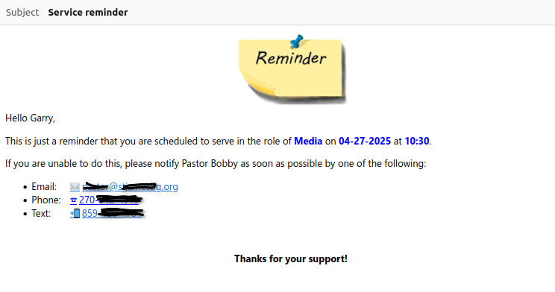
If you would like to have Scheduler send these reminders automatically, you can do so by selecting Automatic Reminders under the Administrative options.

Administrative
Their are several administrative tasks associated with Scheduler that you may need to run from time to time. These include system settings, making and restoring backups, and setting up automatic weekly reminders. All of these tasks are accessed by clicking on the gear icon in the top right corner of the screen:
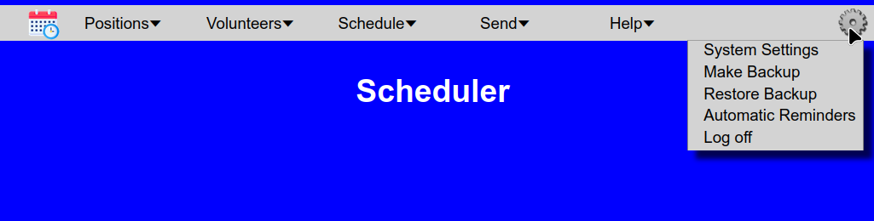

Backups
Once you have configured Scheduler and entered all of your positions and volunteers, you should probably use the backup feature of Scheduler to let you save the information that you have entered in a secure location. Scheduler allows you to both make and restore backups from your browser, so that you can keep the backups separate from the machine where Scheduler is running.

Making Backups
To make backups, click the Make Backup menu entry. Scheduler will then make a backup file and send it to your browser as a download. The backup file will contain all positions, volunteers, configuration, and schedulers that are stored in the system. Using your browser, simply select the name and location that you want to give the backup file and the backup will download to your computer.

Restoring From Backups
To restore your Scheduler system to a prior state from a backup, click the Restore Backup entry. Scheduler will show you this warning screen to remind you that running a restore will replace everything currently in the Scheduler program with the contents of the backup file.
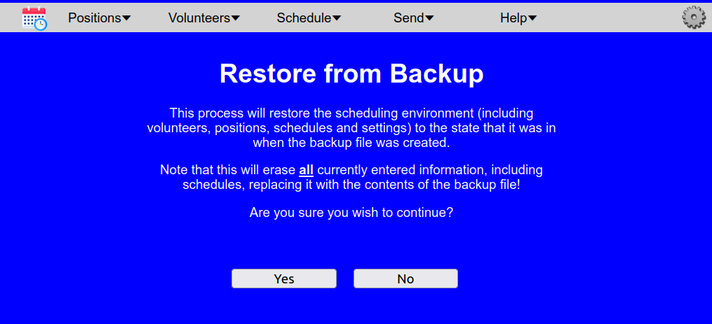
Press Yes to continue with the restore. Your browser will then prompt you to select the backup file that should be used for the restore. Select the file and Scheduler will upload the file and restore the system to its previous state.

Automatic Reminders
Scheduler can send weekly reminders out to each volunteer who is scheduled to volunteer that week, if you desire. To do so, click on the gear icon in the top right corner of the screen and select the Weekly Reminders entry. You will be redirected to this screen:
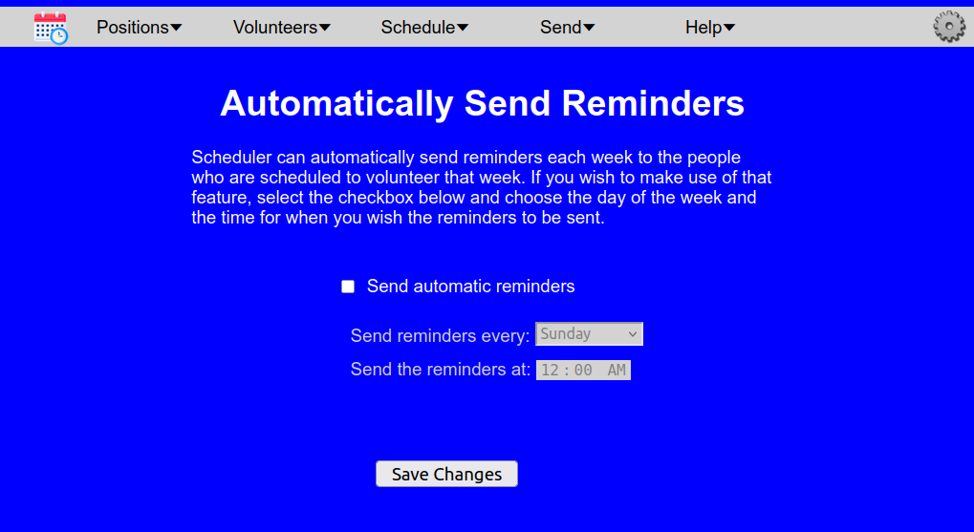
To have Scheduler send reminders, click the “Send automatic reminders” checkbox, and then set the day of the week and time when you would like the reminders to be sent. When you are finished, press the Save Changes button.

System Settings
The Scheduler program can create and print Schedules without having to access any outside service, but to send messages to volunteers, Scheduler uses Gmail to send email, and uses the service Twilio to send text messages. Note that, while Gmail is free, Twilio is a paid service that requires you to set up an account and charges for each text message sent. The System Settings page is where you enter information that Scheduler will use when sending messages using these services. If you choose not to set up these features, please leave the mobile phone or email entries blank when setting up the volunteers.
When you select System Settings you will see a screen like this:

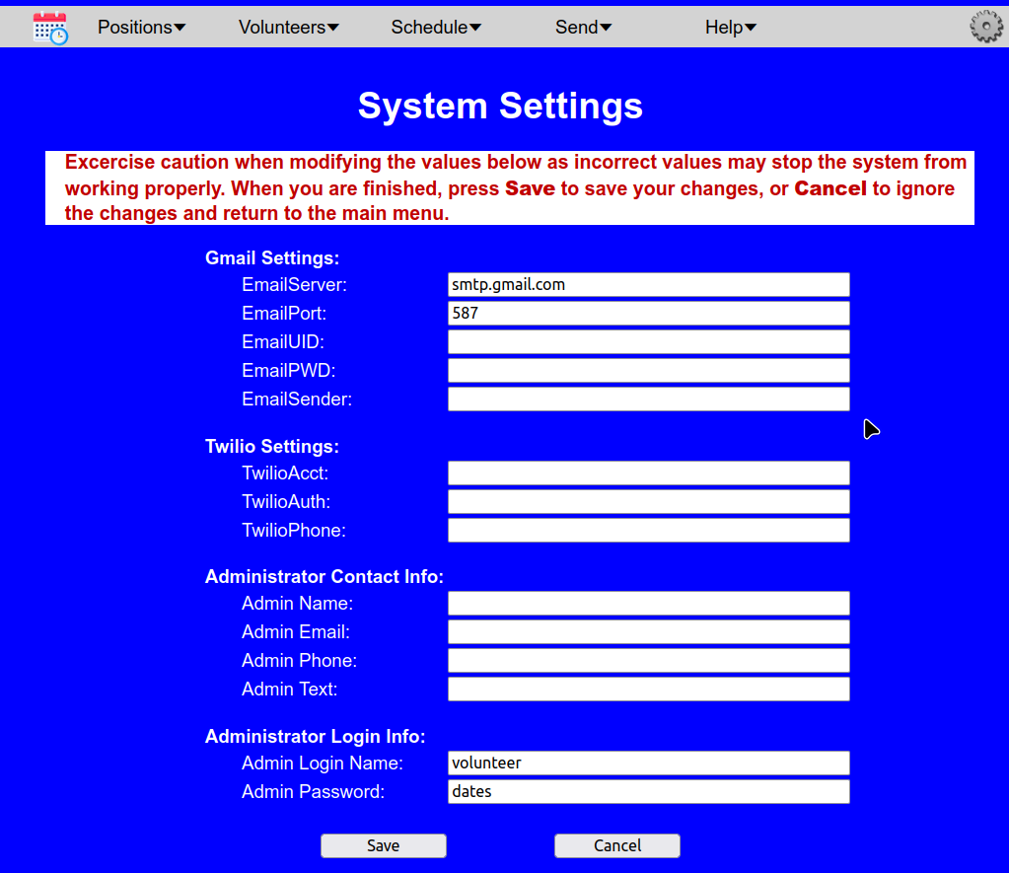
though initially, most of the fields will be blank. The first five entries are values used in setting up Scheduler so that it can send mail through Gmail. The next three entries are values needed to send SMS text messages via Twilio. The next four entries are values that will be placed into outgoing messages, indicating the name of the person who manages the scheduling, and that person’s phone number, text number, and email address. And the last two entries let you set the user name and password to use for logging in. They default to a login name of “volunteer” and a password of “dates”.

Entering Gmail information
The first two entries, EmailServer and EmailPort are the SMTP server values associated with Google Mail. Currently these values are smtp.gmail.com and 587, but these values are not hard-coded, as Google could choose to change them at some point. The value in the EmailSender slot will be used as the name of the person sending the messages that are sent from Scheduler. For the remaining two fields, EmailUID, EmailPWD, you will need to set up a dedicated Google mail (Gmail) account for Scheduler to use and then set up an app password for that account.

Setting up a Gmail account for Scheduler
Google allows you to set up accounts for free, but you may also want to consider setting up a Google Workspace account. Google provides free access to Google Workspace to qualifying nonprofit organizations. For setting up just a basic Google account, their current instructions are:
Important: Before you set up a new Gmail account, make sure to sign out of your current Gmail account. Learn how to sign out of Gmail.
- From your device, go to the Google Account sign in page. (https://accounts.google.com/signin)
- Click Create account.
- In the drop down, select if the account is for your:
  - Personal use
  - Child
  - Work or business
- To set up your account, follow the steps on the screen.
When you have selected the Google account that Scheduler will use for sending email, enter the account name (like ourScheduler@gmail.com) into the EmailUID field on the System Settings page.

Setting up an app password for Scheduler
you then need to set up an app password for the account. This will be the password that Scheduler uses to login to Gmail to send messages. To set up the app password, do the following:
- Go to https://myaccount.google.com and login with the account that Scheduler will be using.
- In the left hand menu, select “Security”.
- Scroll down to the “How you sign in to Google” section.
- Look for the line that says “2-Step Verification”. Notice whether it says 2-Step Verification is on or off. Your screen should look something like this:
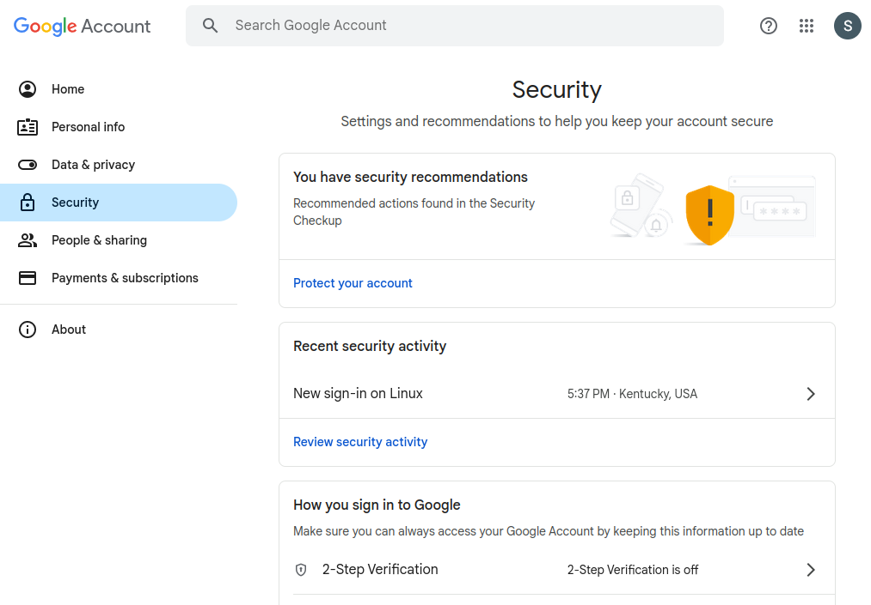
If it is off, click on the right arrow at the end of the line and follow the prompts to turn on 2-Step Verification.
- Now go to https://myaccount.google.com/apppasswords. You will see a screen like this: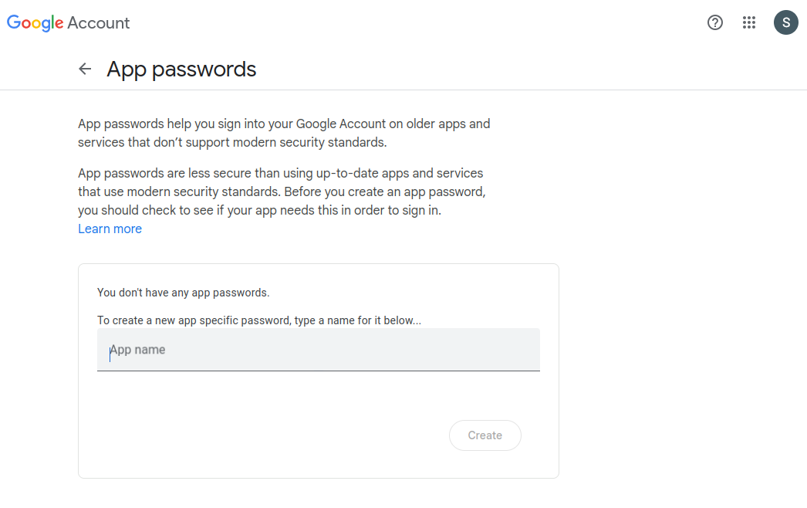
Enter the name for this app (“Scheduler”, for instance) and click Create. You will then see a screen like this:
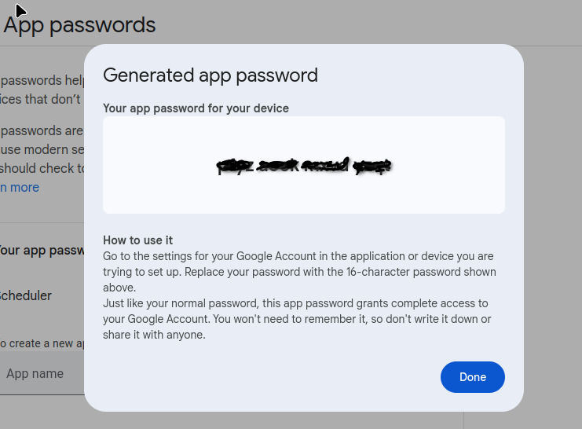
- Make note of the 16 character app password. This is the value that will go into the EmailPWD field in the System Settings page in Scheduler.

Twilio Information
The information that Scheduler needs for sending messages via Twilio can be found on the Twilio Account Dashboard. When you login to your Twilio account dashboard page and scroll down until you see the Account Info section. It should look something like this:
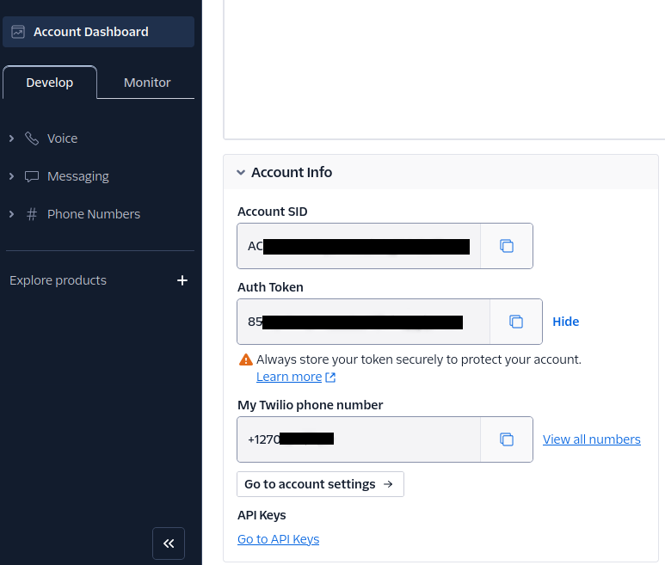
Copy the value from the Account SID field and enter it into the TwilioAcct field in the Scheduler System Settings page. Similarly, copy the Auth Token value to the TwilioAuth field, and copy the My Twilio phone number value to the Twilio Phone field.

Administrator Contact Info
The messages that Scheduler sends out ask people to contact the person in charge of running Scheduler, in the event that they have questions or problems. The last four lines allow you to provide information about who volunteers should contact, and how they may contact that person.

